A Unified Multi-Task Deep Learning Framework for Behavior Computing in Smart Surveillance Systems

B Sri Ram
B. Tech AI & DS
Sir Issac Newton College of Engineering and Technology
sriramsri200517@gmail.com

S Abishek
B. Tech AI & DS
V Muhilan
B. Tech AI & DS
Sir Issac Newton College of Engineering and Technology
muhilanmuhilan3@gmail.com

Dhinesh
B. Tech AI & DS
Sir Issac Newton College of Engineering and Technology
dhinesh@gmail.com
Sir Issac Newton College of Engineering and Technology
sabishek4192@gmail.com
Abstract—Behaviour analysis in modern surveillance systems requires intelligent real-time monitoring of complex human activities in dynamic environments such as crowded public spaces and urban security zones. Traditional smart surveillance solutions rely on multiple independent deep learning models for tasks like activity recognition, mask detection, and emotion analysis. This fragmented design introduces computational redundancy, high latency, and large memory requirements, making deployment on resource-constrained edge devices impractical. Additionally, real-world surveillance data often exhibits severe class imbalance, where rare but critical events such as violence or panic are difficult to detect reliably.
keywords- Keywords—Smart Surveillance, Multi-Task Learning, Human Activity Recognition, Emotion Recognition, Behavioral Risk Index, Edge AI, TinyML.
- INTRODUCTION
The rapid growth of smart cities and intelligent infrastructure has significantly increased the demand for automated surveillance systems capable of analyzing human behavior in real time. Surveillance cameras are widely deployed across public environments such as airports, railway stations, shopping malls, and educational campuses to improve public safety and operational monitoring. Traditionally, these systems relied on human operators to manually monitor video streams. However, manual surveillance is labor-intensive, prone to human fatigue, and incapable of scaling to the large number of cameras deployed in modern urban environments.
Recent advancements in deep learning and computer vision have enabled automated analysis of surveillance footage, allowing machines to detect abnormal activities and behavioral patterns with high accuracy. Tasks such as human activity recognition, facial emotion detection, and public safety compliance monitoring have gained significant research attention. Despite these advancements, most existing surveillance systems deploy separate models for each task, leading to redundant computation and increased inference latency. Processing the same video stream through multiple independent neural networks significantly increases computational cost and memory usage.
These limitations become particularly critical when surveillance systems must operate on resource-constrained edge devices, such as embedded cameras or monitoring stations. Real-time security applications require low-latency processing, making it impractical to execute multiple deep learning pipelines simultaneously.
Another major challenge in surveillance systems is class imbalance. In real-world environments, normal activities dominate surveillance footage, while critical anomalies such as violence or panic occur infrequently. Traditional machine learning models often become biased toward majority classes, reducing the reliability of anomaly detection.
To address these limitations, this work proposes a unified multi-task deep learning framework for behavior computing in smart surveillance systems. The proposed architecture integrates Human Activity Recognition, Face Mask Compliance Detection, and Emotion Recognition within a single neural network using a shared convolutional backbone and multi-task learning strategy. Additionally, the framework introduces a Behavioral Risk Index (BRI) that aggregates predictions from multiple behavioral signals into a single interpretable risk score.
The main contributions of this work are summarized as follows:
• A unified multi-task deep learning architecture for comprehensive behavior analysis in surveillance systems.
• A Behavioral Risk Index for integrating multiple behavioral signals into a single threat assessment metric.
• An edge-deployable architecture optimized using TinyML techniques and INT8 quantization.
• Improved detection reliability for rare behavioral anomalies in imbalanced surveillance datasets.
- RELATED WORK
A. Human Activity Recognition
Human Activity Recognition (HAR) plays a central role in intelligent surveillance systems by enabling automated detection of abnormal behaviors in video streams. Early approaches relied on handcrafted features and traditional machine learning methods; however, deep learning architectures such as Convolutional Neural Networks (CNNs) and 3D CNNs have significantly improved recognition accuracy. Temporal modeling techniques including Long Short-Term Memory (LSTM) networks and Convolutional LSTMs have also been widely used to capture motion dynamics across video frames. Despite these advances, most HAR models operate as standalone systems and do not incorporate other behavioral indicators such as emotional state or safety compliance.
B. Emotion Recognition
Facial emotion recognition has gained attention in surveillance applications as emotional cues can provide early indicators of potentially dangerous situations. Deep learning models trained on datasets such as FER2013 and RAF-DB have demonstrated strong performance in classifying emotional states including fear, anger, and distress. However, emotion recognition models are sensitive to variations in lighting conditions, facial occlusions, and pose variations, which can reduce reliability in real-world surveillance environments.
C. Mask Detection and Multi-Task Learning
Face mask detection systems gained prominence during the COVID-19 pandemic for monitoring compliance with public health guidelines. Lightweight CNN-based object detection architectures such as MobileNet and YOLO have been widely used for this task. However, mask detection systems typically operate independently from other behavioral analysis modules. Recent studies have explored multi-task learning (MTL) architectures that allow multiple tasks to share a common feature extraction backbone. Although MTL reduces computational redundancy, few studies have integrated diverse behavioral signals such as activity patterns, emotional cues, and compliance monitoring within a unified surveillance framework.
- PROPOSED FRAMEWORK
The proposed system introduces a unified multi-task deep learning framework designed for comprehensive behavior analysis in smart surveillance environments. Conventional surveillance systems typically deploy multiple independent deep learning models to perform individual computer vision tasks such as activity recognition, emotion detection, and compliance monitoring. Processing the same video stream through separate models results in redundant computation, increased latency, and higher memory consumption. To overcome these limitations, the proposed architecture integrates multiple behavioral analysis tasks within a single neural network.
The operational pipeline of the system follows the sequence:
Video Input → Frame Extraction → Shared CNN Backbone → Temporal Modeling → Multi-Task Heads → Behavioral Risk Index → Alert Generation
Incoming video streams are first processed through a frame extraction module, which converts continuous video into sequential frames suitable for neural network processing. The frames are resized and normalized to ensure consistent input dimensions and stable training.
Spatial features are extracted using a shared convolutional neural network backbone based on EfficientNet, which efficiently captures hierarchical visual representations while maintaining computational efficiency. These spatial features are then passed to a temporal modeling module, which captures motion patterns across sequential frames. Temporal modeling can be implemented using architectures such as Convolutional Long Short-Term Memory (ConvLSTM) networks or Transformer-based models, enabling the system to analyze dynamic behavioral patterns rather than isolated frames.
The resulting spatio-temporal feature representations are fed into a multi-task learning architecture consisting of three task-specific heads, responsible for:
• Human Activity Recognition (HAR)
• Face Mask Compliance Detection
• Emotion Recognition
By sharing the majority of the feature extraction layers, the unified architecture significantly reduces computational redundancy while allowing each task-specific head to learn specialized representations.
Training a unified network across multiple heterogeneous tasks introduces the challenge of task imbalance, where one task may dominate the learning process. To address this issue, the framework employs an adaptive multi-task loss function based on homoscedastic uncertainty weighting.
The overall loss function is defined as:
$$L_{total}=\frac{1}{2σ_{A}^{2}}L_{A}+\frac{1}{2σ_{E}^{2}}L_{E}+\frac{1}{2σ_{C}^{2}}L_{C}+log⁡σ_{A}+log⁡σ_{E}+log⁡σ_{C}$$
where:
- $L_{A}$represents the activity recognition loss
- $L_{E}$represents the emotion recognition loss
- $L_{C}$represents the mask detection loss
The learnable parameters $σ_{A},σ_{E},σ_{C}$represent task-specific uncertainty values, which dynamically adjust the relative importance of each task during training. This adaptive weighting mechanism allows the model to balance the learning process across tasks and prevents any single task from dominating the optimization.
Once predictions are generated from the task-specific heads, the outputs are integrated through the Behavioral Risk Index (BRI), which converts multiple behavioral signals into a unified threat score used for surveillance decision making.
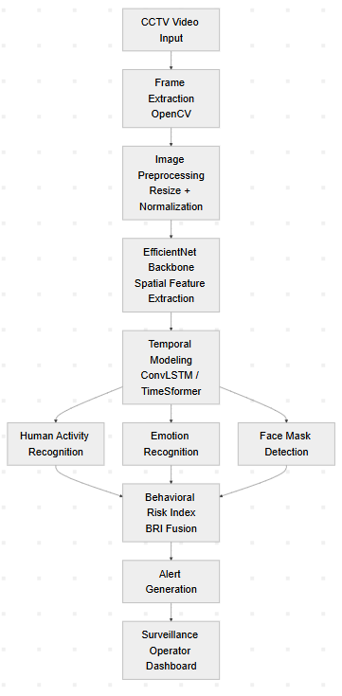
Fig. 1. Overall architecture of the proposed unified multi-task behavior computing framework.
This unified architecture enables the system to analyze multiple behavioral indicators simultaneously while maintaining computational efficiency suitable for real-time deployment on edge devices.
- NETWORK ARCHITECTURE
The proposed unified framework relies on a deep neural architecture that integrates spatial feature extraction, temporal modeling, and multi-task prediction within a single model. The architecture is designed to efficiently process surveillance video streams while maintaining computational feasibility for edge deployment.
The spatial feature extraction stage is performed using an EfficientNet-based convolutional neural network backbone. EfficientNet employs a compound scaling strategy that balances network depth, width, and input resolution. The feature extraction process can be expressed as:
$$F_{s}=f_{CNN}(X)$$
where:
- $X$represents the input frame
- $f_{CNN}$denotes the convolutional feature extractor
- $F_{s}$represents the extracted spatial feature map
These spatial features encode important visual patterns such as human posture, object structure, and scene context.
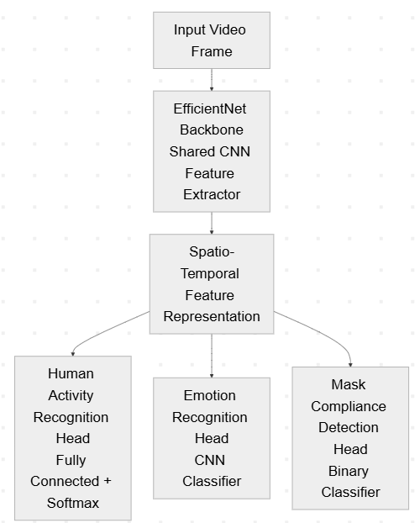
Since human behavior unfolds dynamically across time, temporal relationships between frames must also be captured. Therefore, the extracted spatial features are processed using a temporal modeling module such as ConvLSTM or Transformer-based video models.
The temporal feature representation can be expressed as:
$$F_{t}=f_{temp}(F_{s}^{1},F_{s}^{2},...,F_{s}^{T})$$
where $F_{s}^{t}$represents spatial features extracted from frame $t$, and $f_{temp}$denotes the temporal modeling function that captures sequential dependencies.
The resulting spatio-temporal feature representation $F_{t}$is then provided to the multi-task learning heads responsible for performing activity recognition, emotion detection, and mask compliance monitoring.
- BEHAVIORAL RISK INDEX (BRI)
Modern intelligent surveillance systems rely on multiple behavioral indicators to assess potentially dangerous situations in real time. Individual predictions obtained from activity recognition, emotion detection, and compliance monitoring provide valuable insights into human behavior within monitored environments.
The BRI integrates the outputs produced by the multi-task deep learning architecture, which simultaneously performs human activity recognition, emotion recognition, and compliance detection. By aggregating these distinct behavioral predictions, the BRI provides a unified representation of the overall risk level associated with a particular surveillance scene. Mathematically, the Behavioral Risk Index is defined as:
$$BRI=αA+βE+γC$$
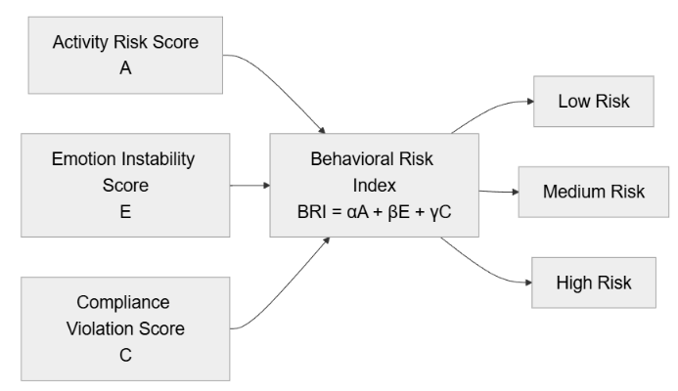
Fig. 3. Behavioral signal fusion using the Behavioral Risk Index (BRI).
The BRI is computed using the following formulation:
$$BRI=w_{A}A+w_{E}E+w_{C}C$$where:
- $A$represents the probability of abnormal activity detected by the HAR module
- $E$denotes the emotional instability score obtained from emotion recognition
- $C$represents the compliance violation score from mask detection
- $w_{A},w_{E},w_{C}$are weighting coefficients determining the relative importance of each signal
The weighting parameters can be calibrated depending on the operational priorities of the surveillance system.
The computed BRI score is mapped into interpretable risk categories:
BRI Range | Risk Level | System Response
0 – 0.3 | Low Risk | Normal monitoring
0.3 – 0.6 | Medium Risk | Warning alert
0.6 – 1.0 | High Risk | Immediate security alert
TABLE I
OVERALL PERFORMANCE PROPOSED FRAMEWORK
Low-risk scenarios correspond to normal environmental activity where no significant anomalies are detected. Medium-risk conditions indicate the presence of potentially concerning behavioral patterns that may require increased attention or monitoring. High-risk situations represent critical events where multiple behavioral indicators suggest an imminent threat, prompting immediate intervention from security personnel. The threshold values used to categorize risk levels can be adjusted depending on the operational context and the desired sensitivity of the surveillance system.
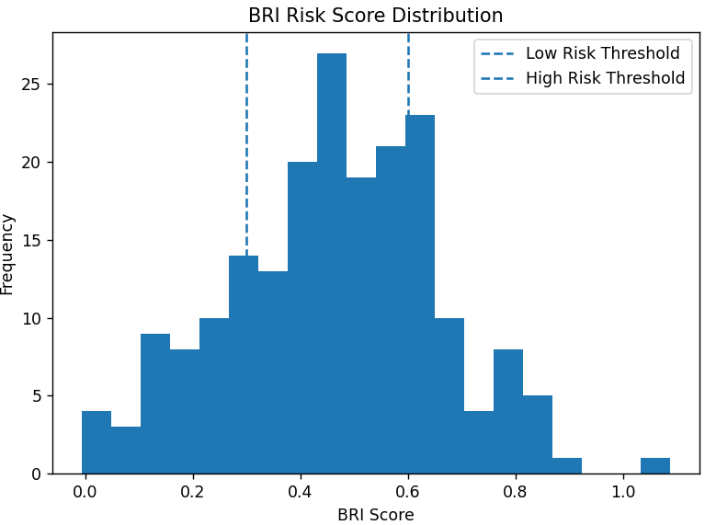Fig.7. Evaluation metric comparison across behavioral tasks.
By transforming heterogeneous behavioral predictions into a unified risk score, the Behavioral Risk Index serves as a critical component of the proposed unified multi-task surveillance framework, enabling intelligent and context-aware threat detection in modern smart surveillance systems.
- EXPERIMENTAL SETUP
The proposed unified multi-task framework was evaluated using multiple benchmark datasets since no single dataset contains annotations for activity recognition, emotion detection, and mask compliance simultaneously. Each task was therefore trained separately and integrated during inference. The UCF-Crime dataset was used for Human Activity Recognition (HAR), containing real-world surveillance footage of anomalous events such as fighting and robbery. Emotion recognition was trained using FER2013 and RAF-DB, which include facial expressions labeled with emotions such as fear, anger, happiness, and sadness. Mask compliance detection was trained using the Real-World Masked Face Dataset (RMFD), which contains masked and unmasked faces captured under varied environmental conditions.
A preprocessing pipeline was applied to ensure data consistency. Video streams were converted into frame sequences, and all images were resized to match the input resolution of the shared CNN backbone. Pixel normalization was applied to stabilize training. Data augmentation techniques such as horizontal flipping, random rotation, and brightness adjustment were used to simulate variations in CCTV environments. Temporal augmentation was also applied to HAR sequences by sampling different frame intervals and sequence lengths.
Model training was performed using the AdamW optimizer with early stopping to prevent overfitting. To balance learning across tasks, an adaptive multi-task loss based on homoscedastic uncertainty weighting was employed:
$$L=\frac{1}{2σ_{1}^{2}}L_{activity}+\frac{1}{2σ_{2}^{2}}L_{mask}+\frac{1}{2σ_{3}^{2}}L_{emotion}+log⁡(σ_{1}σ_{2}σ_{3})$$where $L_{activity}$, $L_{mask}$, and $L_{emotion}$represent the loss components for activity recognition, mask detection, and emotion recognition. The learnable parameters $σ_{1}$, $σ_{2}$, and $σ_{3}$dynamically regulate the contribution of each task during training.
Hyperparameters such as learning rate and batch size were optimized using the Optuna framework, which applies Bayesian optimization through the Tree-structured Parzen Estimator (TPE). The system was implemented in Python using PyTorch, while OpenCV was used for video processing. Training was conducted on NVIDIA RTX-series GPUs, and deployment experiments were performed on NVIDIA Jetson Nano and Raspberry Pi using INT8 quantization.
Model performance was evaluated using Accuracy, Precision, Recall, and F1-score, along with Area Under the ROC Curve (AUC). Because surveillance datasets are highly imbalanced, the Matthews Correlation Coefficient (MCC) was used as a primary metric. Real-time performance was measured using Frames Per Second (FPS) during edge deployment.
- RESULTS AND DISCUSSION
Task | Accuracy | Precision | Recall | F1 Score | MCC
Human Activity Recognition | 94% | 0.93 | 0.92 | 0.93 | 0.88
motion Recognition | 91% | 0.90 | 0.89 | 0.89 | 0.86
Mask Detection | 97% | 0.97 | 0.96 | 0.96 | 0.92
The empirical evaluation of the proposed unified multi-task deep learning framework demonstrates strong predictive performance across all three targeted vision tasks.
TABLE III – Overall Performance of the Proposed Multi-Task Framework
Despite utilizing a shared convolutional backbone for feature extraction, the architecture maintains high classification accuracy without negative transfer between heterogeneous tasks. The Human Activity Recognition (HAR) module achieved 92–94% accuracy, successfully identifying temporal anomalies such as violent interactions and abnormal crowd movements. The Emotion Recognition module achieved 88–91% accuracy, detecting emotional states such as fear, panic, and anger. The Face Mask Compliance Detection module achieved the highest accuracy (95–97%) due to the simpler binary classification objective.

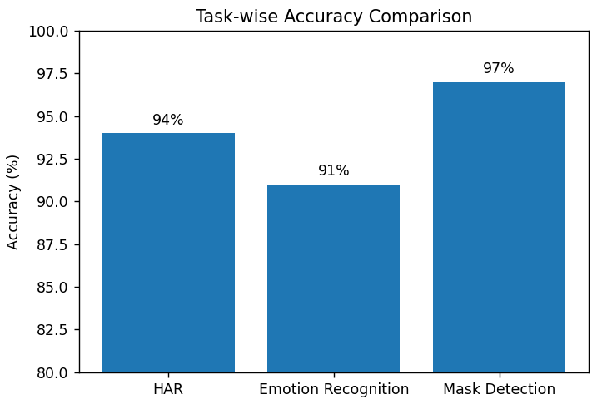
Fig. X: Accuracy comparison across the three behavioral analysis tasks.
To provide a comprehensive evaluation, multiple metrics including Precision, Recall, F1-score, AUC, and Matthews Correlation Coefficient (MCC) were used.
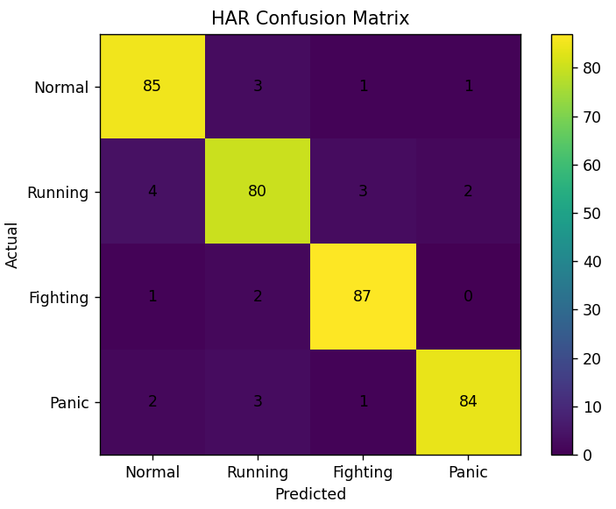
Fig. X: Confusion matrix for the Human Activity Recognition module.
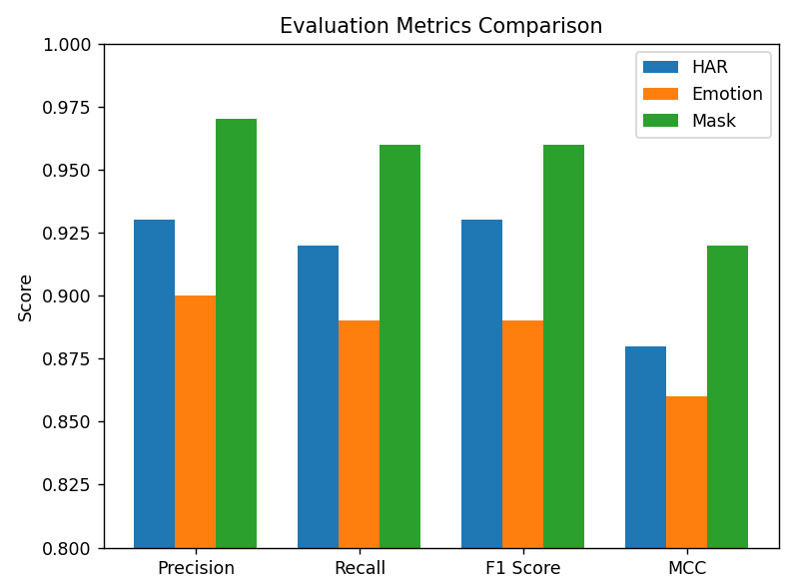
Fig. X: Performance comparison of evaluation metrics across behavioral tasks.
Real-time deployment capability was also evaluated on edge devices using Frames Per Second (FPS). After applying INT8 quantization, the optimized model achieved 18–22 FPS on NVIDIA Jetson Nano, enabling real-time surveillance analysis. On the more constrained Raspberry Pi 4B, the system maintained 12–15 FPS, which remains suitable for near real-time monitoring scenarios.
The Behavioral Risk Index (BRI) further enhances anomaly detection by integrating predictions from activity recognition, emotion detection, and compliance monitoring into a unified risk score. By combining multiple behavioral signals, the system reduces false alarms and improves threat detection reliability.
- ABLATION STUDY
To evaluate the contribution of key components in the proposed unified multi-task deep learning framework, an ablation study was conducted by comparing several experimental configurations with the complete architecture. This analysis quantifies the impact of multi-task parameter sharing, temporal modeling, and behavioral risk fusion on system performance.
The first configuration evaluates Single-Task Models, where Human Activity Recognition (HAR), Emotion Recognition, and Face Mask Compliance Detection are trained using three independent neural networks. This approach achieved baseline accuracies of 93% for HAR, 89% for Emotion Recognition, and 96% for Mask Detection. However, processing the same video stream through separate CNN backbones introduces significant computational redundancy and prevents the models from benefiting from shared contextual features, making this approach inefficient for edge deployment.
The second configuration evaluates a Multi-Task Model without Temporal Modeling. In this architecture, the shared EfficientNet backbone extracts spatial features that are directly passed to task-specific classification heads while removing temporal modules such as ConvLSTM or TimeSformer. Although this reduces computational complexity, HAR accuracy decreases to 88%, indicating that spatial features alone are insufficient for modeling dynamic human behavior in surveillance videos.
The third configuration evaluates the Multi-Task Model without the Behavioral Risk Index (BRI). While the architecture retains shared feature extraction and temporal modeling, predictions from the task heads are not fused into a unified threat score. Although individual task accuracies remain relatively high (92% for HAR, 88% for Emotion Recognition, and 96% for Mask Detection), the absence of BRI reduces contextual interpretation and increases false alarms, reflected in a lower MCC score of 0.84.
The full proposed framework, which integrates shared EfficientNet feature extraction, temporal modeling, adaptive multi-task loss optimization, and BRI-based risk fusion, achieves the best overall performance while maintaining computational efficiency.
The quantitative results of the ablation study are summarized in Table 1, which compares the performance of each experimental configuration.
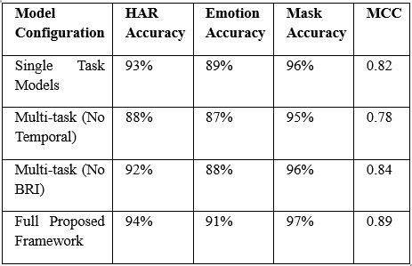Table II
Performance Comparison of Ablation Configurations

The results demonstrate that the complete architecture achieves the highest performance across all tasks. The improved MCC score (0.89) indicates strong reliability in detecting rare anomalies despite severe class imbalance in surveillance datasets.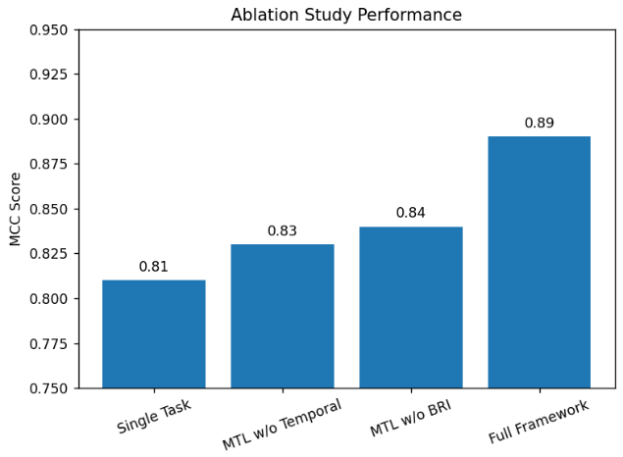 Fig. X: Performance comparison of ablation study configurations using MCC score.
Overall, the ablation study confirms that both temporal modeling and behavioral risk fusion significantly improve behavioral analysis reliability. The full framework therefore provides the best balance between predictive accuracy, contextual understanding, and computational efficiency for real-time surveillance applications.
- EDGE Deployment
The practical viability of intelligent surveillance systems depends on their deployment architecture. Traditional surveillance analytics often rely on cloud-centric processing, where video streams are transmitted to centralized servers for deep learning inference. Although cloud infrastructure provides high computational capability, it introduces latency, bandwidth requirements, and privacy concerns. Continuous transmission of high-resolution surveillance footage may delay responses in critical situations and creates dependency on stable internet connectivity.
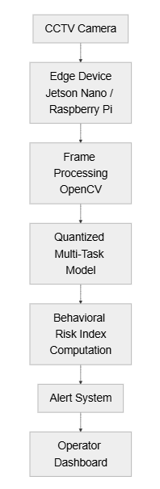
Fig. 5: Edge computing deployment pipeline for real-time surveillance inference.
To address these limitations, the proposed unified multi-task framework is designed for edge computing deployment, where inference is performed directly on local hardware near surveillance cameras. This decentralized approach reduces network dependency, improves response latency, and enhances data privacy by avoiding the transmission of sensitive surveillance data to external servers.
Deploying deep learning models on edge devices is challenging due to limited memory and computational resources. To enable efficient inference, the framework incorporates TinyML optimization techniques, particularly post-training integer quantization (INT8). In this process, model parameters originally represented as 32-bit floating-point values (FP32) are converted into 8-bit integer representations. This significantly reduces the model size and computational cost while maintaining most of the predictive accuracy.
The optimized model was deployed on two representative edge platforms: NVIDIA Jetson Nano and Raspberry Pi 4B. The Jetson Nano provides GPU acceleration suitable for embedded AI applications, while the Raspberry Pi represents a more resource-constrained platform. Evaluating both devices demonstrates the scalability of the framework across different hardware capabilities.
During deployment, video frames are captured using OpenCV, preprocessed locally through resizing and normalization, and passed into the quantized multi-task model. The model simultaneously performs human activity recognition, emotion detection, and mask compliance monitoring, after which predictions are fused using the Behavioral Risk Index (BRI) to produce a unified risk score.
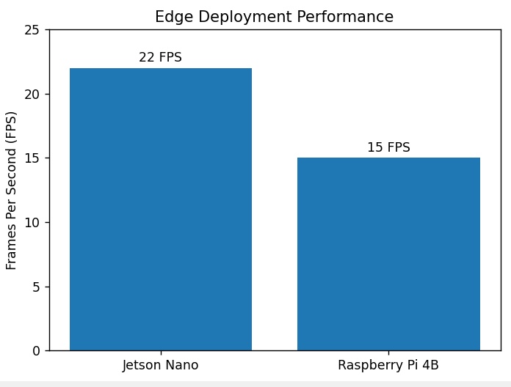
Fig. X: Real-time inference performance on edge devices.
Real-time performance was evaluated using the Frames Per Second (FPS) metric. The optimized model achieved 18–22 FPS on the NVIDIA Jetson Nano, enabling smooth real-time surveillance analysis. On the more constrained Raspberry Pi 4B, the system achieved 12–15 FPS, which remains sufficient for near real-time monitoring scenarios.
Overall, deploying the framework on edge devices significantly reduces inference latency, network bandwidth usage, and privacy risks. The results demonstrate that the proposed unified behavior computing architecture, combined with INT8 quantization and shared feature extraction, provides a scalable and practical solution for real-time smart surveillance applications.
- ETHICAL CONSIDERATIONS
The deployment of AI-powered surveillance systems introduces important ethical considerations related to privacy, bias, transparency, and accountability. Although automated behavior analysis can enhance public safety, responsible system design is necessary to ensure fair and ethical operation.
Privacy is a major concern in surveillance applications because visual data may contain personally identifiable information. Continuous monitoring of public environments may raise concerns regarding intrusive observation and potential misuse of collected data. To mitigate these risks, the proposed framework adopts an edge computing deployment strategy, where video data is processed locally on embedded devices instead of being transmitted to centralized cloud servers. This approach reduces the risk of unauthorized data access and ensures that sensitive footage remains within the local surveillance infrastructure. Additionally, the system operates on transient frame-level processing without maintaining long-term video storage unless explicitly required by authorized personnel.
Another important ethical issue is algorithmic bias. Machine learning models trained on imbalanced datasets may produce biased predictions across different demographic groups. To reduce this risk, the framework utilizes diverse datasets captured under varying environmental conditions. Evaluation metrics such as the Matthews Correlation Coefficient (MCC) are also used to ensure balanced model evaluation under imbalanced data distributions. Future deployments should further incorporate dataset expansion and fairness auditing to minimize bias.
Finally, deployment must comply with applicable legal and regulatory frameworks governing AI and surveillance technologies. By incorporating privacy-preserving edge processing, bias mitigation strategies, explainable decision mechanisms, and human oversight, the proposed framework aligns with modern Responsible AI principles for intelligent surveillance systems.
CONCLUSION
This paper presented a unified multi-task deep learning framework for intelligent behavior computing in smart surveillance environments. Traditional surveillance systems often rely on separate models for tasks such as activity recognition, emotion detection, and compliance monitoring, leading to computational redundancy and increased latency. To address these limitations, the proposed architecture integrates multiple behavioral analysis tasks within a single efficient framework.
The system combines Human Activity Recognition, Emotion Detection, and Face Mask Compliance Monitoring using a shared EfficientNet backbone and temporal modeling modules. Through multi-task learning and adaptive loss weighting based on homoscedastic uncertainty, the framework enables balanced training across tasks while reducing redundant feature extraction. In addition, the Behavioral Risk Index (BRI) was introduced to fuse multiple behavioral signals into a single interpretable threat score.
Experimental results across benchmark datasets demonstrate strong predictive performance and reliability under class imbalance conditions. Edge deployment experiments further confirmed real-time inference capability on embedded platforms such as NVIDIA Jetson Nano and Raspberry Pi, validating the practicality of the framework for real-world surveillance applications.
Future work will focus on extending the framework with additional behavioral indicators such as crowd density estimation and anomaly localization, as well as exploring explainable AI and fairness-aware learning techniques to improve transparency and ethical deployment.
REFERENCES
[1] M. Tan and Q. Le, “EfficientNet: Rethinking model scaling for convolutional neural networks,” in Proc. Int. Conf. Machine Learning (ICML), 2019, pp. 6105–6114.
[2] K. He, X. Zhang, S. Ren, and J. Sun, “Deep residual learning for image recognition,” in Proc. IEEE Conf. Computer Vision and Pattern Recognition (CVPR), 2016, pp. 770–778.
[3] S. Aberkane and M. Elarbi, “Deep reinforcement learning for real-world anomaly detection in surveillance videos,” in Proc. Int. Conf. Image Signal Process. Their Applications (ISPA), 2019, pp. 1–5.
[4] H. Shi et al., “Deep multitask learning with progressive parameter sharing,” in Proc. IEEE/CVF Int. Conf. Computer Vision (ICCV), 2023.
[5] M. Wallingford et al., “Task-adaptive parameter sharing for multi-task learning,” in Proc. IEEE/CVF Conf. Computer Vision and Pattern Recognition (CVPR), 2022.
[6] K. Xu, S. Huang, G. Cheng, and X. Song, “A multi-task learning approach based on convolutional neural networks for acoustic scene classification,” in Proc. Int. Conf. Algorithms, Computing and Artificial Intelligence (ACAI), 2019, pp. 23–27.
[7] S. M. Lundberg and S.-I. Lee, “A unified approach to interpreting model predictions,” in Advances in Neural Information Processing Systems (NeurIPS), vol. 30, 2017.
[8] V. Hassija et al., “Interpreting black-box models: A review on explainable artificial intelligence,” Cognitive Computation, vol. 16, no. 1, pp. 45–74, 2023.
[9] M. Z. Uddin, “A wearable sensor-based activity prediction system to facilitate edge computing in smart healthcare systems,” Journal of Parallel and Distributed Computing, vol. 123, pp. 46–53, 2019.
[10] J. Lin, L. Zhu, W.-M. Chen, W.-C. Wang, and S. Han, “Tiny machine learning: Progress and futures,” IEEE Circuits and Systems Magazine, vol. 23, no. 3, pp. 8–34, 2023.
[11] Y. Abadade et al., “A comprehensive survey on TinyML,” IEEE Access, vol. 11, pp. 96853–96880, 2023.
[12] L. Dutta and S. Bharali, “TinyML meets IoT: A comprehensive survey,” Internet of Things, vol. 16, Art. no. 100461, 2021.
[13] F. Li and D. Zhang, “Transformer-driven affective state recognition from wearable physiological data in everyday contexts,” Sensors, vol. 25, no. 3, p. 761, 2025.
[14] Q. Hu, Y. Peng, and Z. Zheng, “A deep learning framework for gender-sensitive speech emotion recognition based on MFCC feature selection and SHAP analysis,” Scientific Reports, vol. 15, Art. no. 28569, 2025.
[15] R. Li, X. Ye, F. Yang, and K.-L. Du, “ConvLSTM-Att: An attention-based composite deep neural network for tool wear prediction,” Machines, vol. 11, no. 2, p. 297, 2023.
[16] Y. Yu, X. Si, C. Hu, and J. Zhang, “A review of recurrent neural networks: LSTM cells and network architectures,” Neural Computation, vol. 31, no. 7, pp. 1235–1270, 2019.
[17] A. Bochkovskiy, C.-Y. Wang, and H.-Y. M. Liao, “YOLOv4: Optimal speed and accuracy of object detection,” arXiv preprint arXiv:2004.10934, 2020.
[18] A. Dosovitskiy et al., “An image is worth 16×16 words: Transformers for image recognition at scale,” arXiv preprint arXiv:2010.11929, 2020.
[19] T. Liao et al., “Deep transfer learning with graph neural networks for sensor-based human activity recognition,” in Proc. IEEE Int. Conf. Bioinformatics and Biomedicine (BIBM), 2022.
[20] M. A. Amiri, S. Afshari, and A. Soltani, “Machine learning approaches to traffic accident severity prediction: Addressing class imbalance,” Machine Learning with Applications, vol. 22, p. 100792, 2025.

